Calibration curve of Copper sulfate

A solution of copper(II) sulfate (CuSO4) is blue and the intensity of the colour directly relates to the solution’s concentration. Several methods can be used to determine the colour’s intensity. For example, a simple light meter will measure the intensity of light passing through a solution. The more light that is absorbed, the more concentration the solution is. However, a colorimeter shines light a specific wavelength through a sample and measures an absorbance value similarity to an atomic absorption spectrometer.

A spectrophotometer contains a light source, focusing lenses, a diffraction grating or prism to split light into different wavelengths, a sample holder or "cell", a photosensitive detector which measures the light passing through the sample, an amplifier, and an output device such as a meter or recorder.

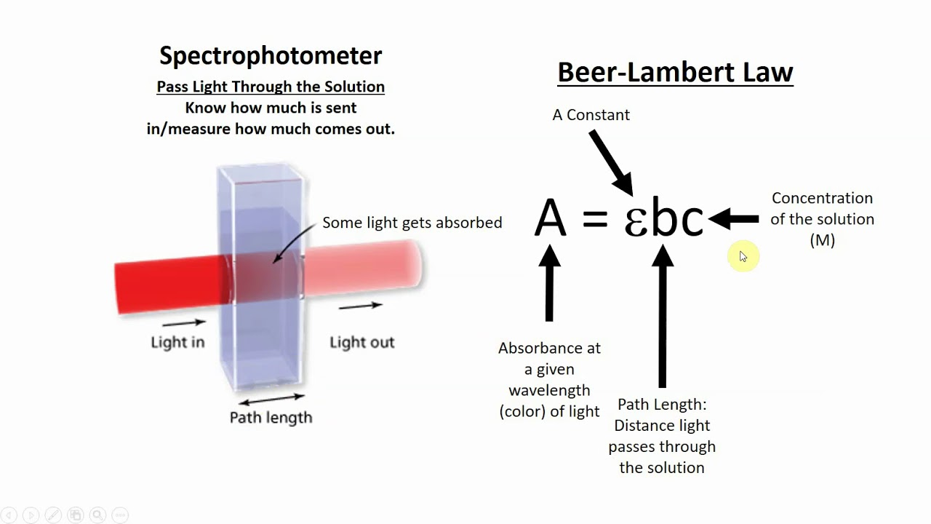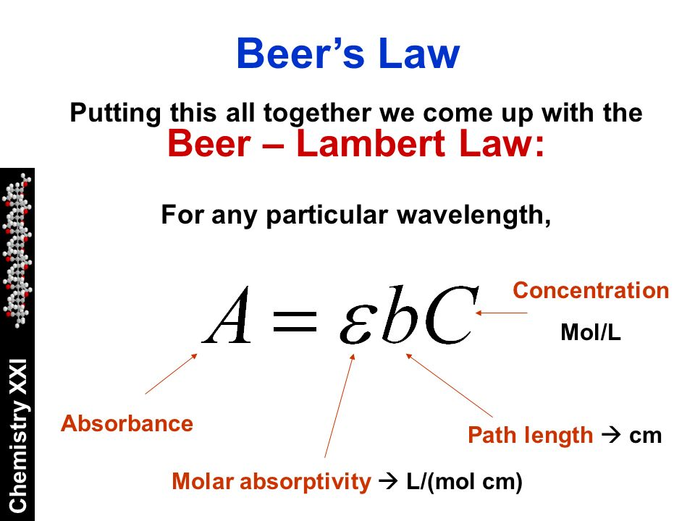

**Beer’s Law**

Beer’s law states the absorbance is directly proportional to the concentration of a solution. If you plot the absorbance (y-axis) versus the concentration (x- axis) you can determine the concentration of an unknown solution using the graph or by using the equation for a line.

In this experiment, you will measure the intensity of light passing through different concentrations of copper(II) sulfate solutions and construct a calibration curve. You will then be given a copper(II) sulfate sample of unknown concentration and will use your calibration curve to determine the solution’s concentration.

Aims

To determine the concentration of a copper(II) sulfate solution by constructing and using a calibration curve.

Apparatus/Equipment

* Light source and light meter, colourimeter - alternatively spectrometer.
* 35 mL of 1 molL-1 CuSO4
* Distilled water
* 50mL beaker
* 10mL measuring cylinder

Risk Assessment

|  |  |
| --- | --- |
| What are the risks in doing this experiment? | How can you manage these risks to stay safe? |
| Use of chemicals   * Chemical spillage * Contact with skin | * Keep open containers on bench, use stoppers * Handle chemical containers with care |
| Use of light meter or data logger   * Device breaking | * Use device responsibly, follow usage instructions |

Procedure/Method

**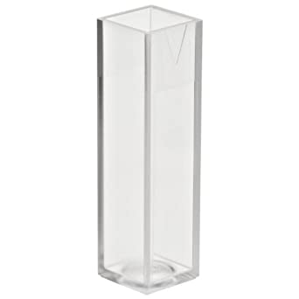***Dilution preparation*

In a 50mL beaker prepare a dilution measured using the table below. Be sure to label your beaker with the concentration.

|  |  |  |
| --- | --- | --- |
| **Concentration Label** | **CuSo4 (mL)** | **H20**  **(mL)** |
| 1 mol L-1 | 10 | 0 |
| 0.8 mol L-1 | 8 | 2 |
| 0.5 mol L-1 | 5 | 5 |
| 0.4 mol L-1 | 4 | 6 |
| 0.2 mol L-1 | 2 | 8 |
| 0 mol L-1 ***(reference)*** | 0 | 10 |

The wavelength of light that will be used in this experiment is **600 nm**.

**Cuvette Preparation:**

1. The unclear sides have ridges or are rough to allow easy handling and to help place the cuvette in the correct position.
2. To prevent spilling and ensure a good measurement, fill a cuvette with solution to about 75% of its total volume.
3. Wipe the outside of a cuvette with a Kimwipe before placing it in the sample holder. (Ensure correct orientation)
4. Beads of water, fingerprints, or bubbles in the solution interfere with transmission of light through the sample.

**Procedure:**

1. Turn on the spectrophotometer and allow it to warm up for 20 minutes

* Set the wavelength to 600nm
* Deuterium lamp – OFF
* Mode – Absorbance

1. Prepare cuvettes with CuSO4 solutions.
2. Distilled water in cell #1
3. Known samples into cell #2, #3, #4, #5
4. Unknown sample into cell #6
5. Close lid
6. Press **Cell Number** to move cell carousel into position
7. Ensure cell #1 is in position and press **Set Reference** (should read 0.00)
8. Press **Cell Number** to move cells and read and record the absorbance values.
9. Create your Beer’s Law Plot to determine the concentration of the unknown CuSO4.

Results

1. Construct a table showing your known concentrations and their absorbances. Include the result for the unknown concentration in this table.
2. Construct a fully labelled calibration curve for your known results.
3. Use the graph to determine the concentration of the unknown sample by interpolation.

|  |  |
| --- | --- |
| **Copper sulfate (CuSO4) [concentration] mol L-1** | **Absorbance (nm)** |
| 0.0 | -0.001 |
| 0.2 | 0.129 |
| 0.4 | 0.308 |
| 0.5 | 0.710 |
| 0.8 | 0.857 |
| 1.0 | 0.936 |
| 0.2717 | 0.273 |

Questions

1. Did your graph pass through the origin (0,0)? Why should you expect it to? Suggest reasons why your graph might not do this.
2. Compare your results with other groups. Did you all get the same answer? If possible, create a table showing a class set of results. Account for any differences between the results.

Discussion

1. If your teacher can tell you the correct concentration of the unknown sample, discuss the accuracy of your results (that is, how close your results were to the true value).
2. Identify one error that may have affected your results. Discuss its effect on the results. Identify the error as random or systematic.

Conclusion

Write a conclusion discussing the results of this experiment.